Name(s): | Nisham Karki
Scoring Criteria are available at the Moodle submission site. Use these as a checkoff before you submit your work.

Include images of your results below: These images should be clipped so that they show only the desired results as shown in the lab manual. Insert as much space as you need but keep all text present in this lab sheet intact. Feel free to insert any comments you would like, especially if you did something above and beyond the requirements that you think should be considered for extra credit.

Be sure to check for anything that might generate penalty points as indicated on the submission site.

- Paste a screen shot of full tetris window showing the LongBrick in its initial position.

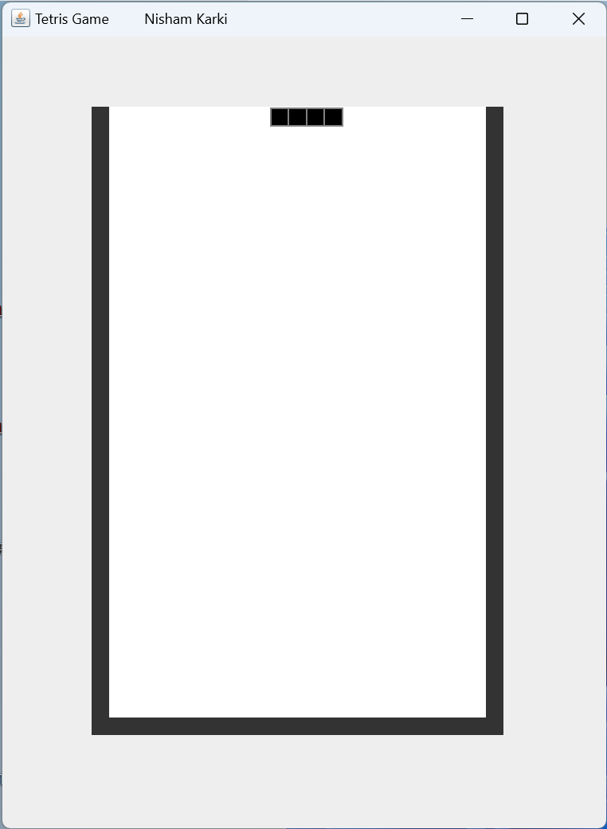

- Paste a screen shot of full tetris window showing the SquareBrick in its initial position.

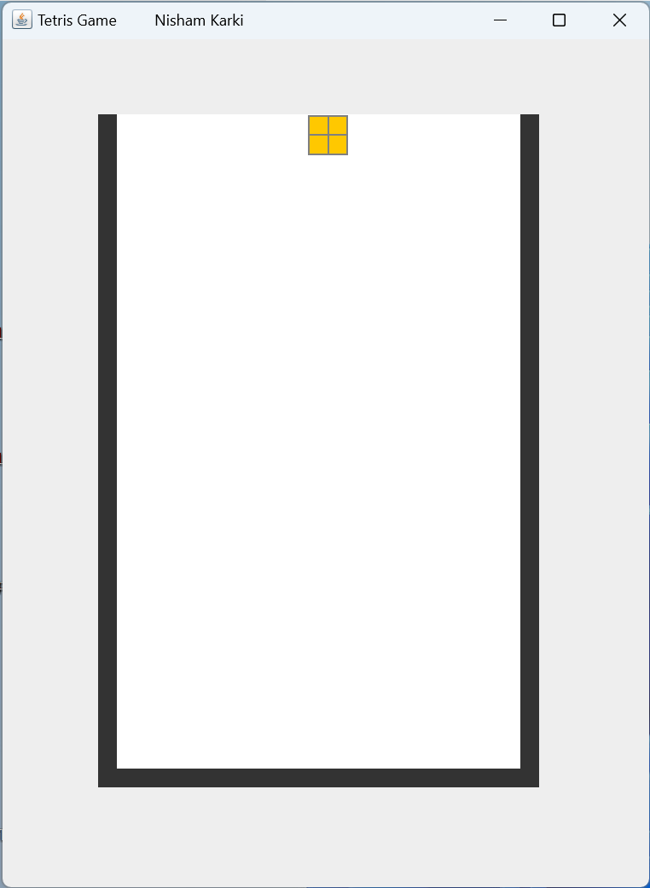

- Paste a screen shot of full tetris window showing the StackBrick in its initial position.

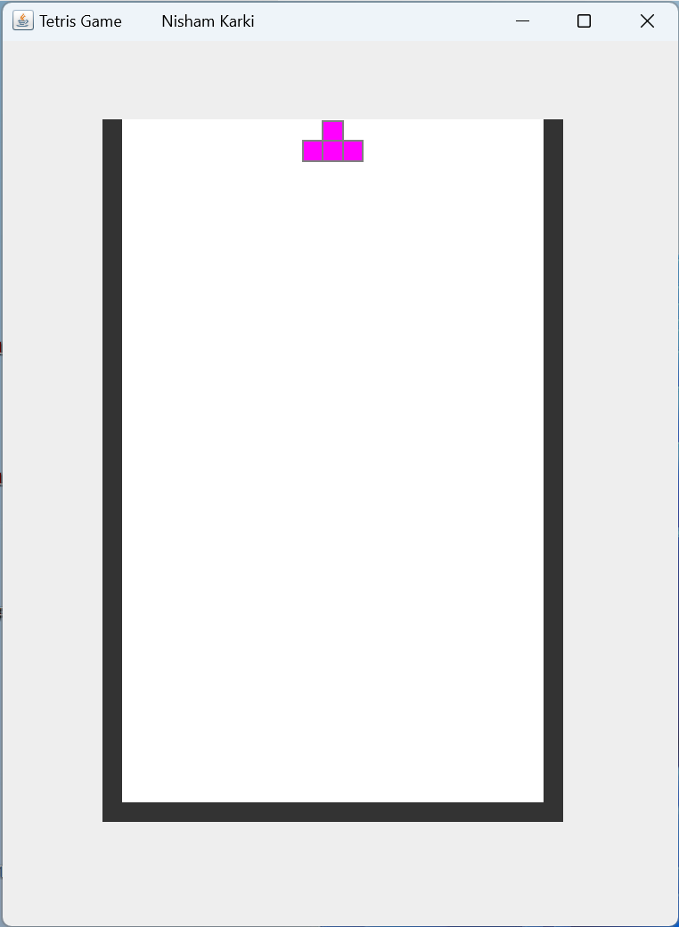
- Paste a screen shot of full tetris window showing the ElBrick in its initial position.

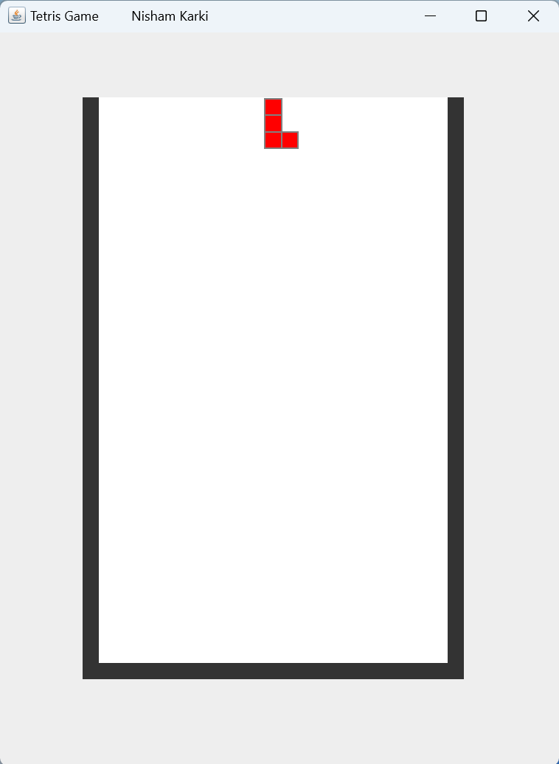

- Paste a screen shot of full tetris window showing the JayBrick in its initial position.

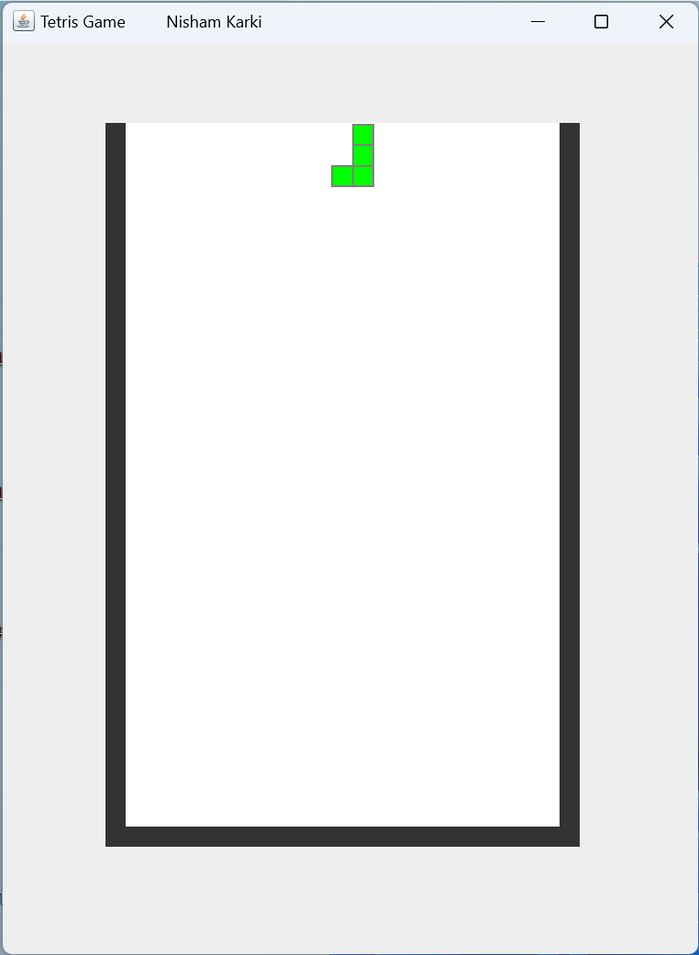

- Paste a screen shot of full tetris window showing the EssBrick in its initial position.

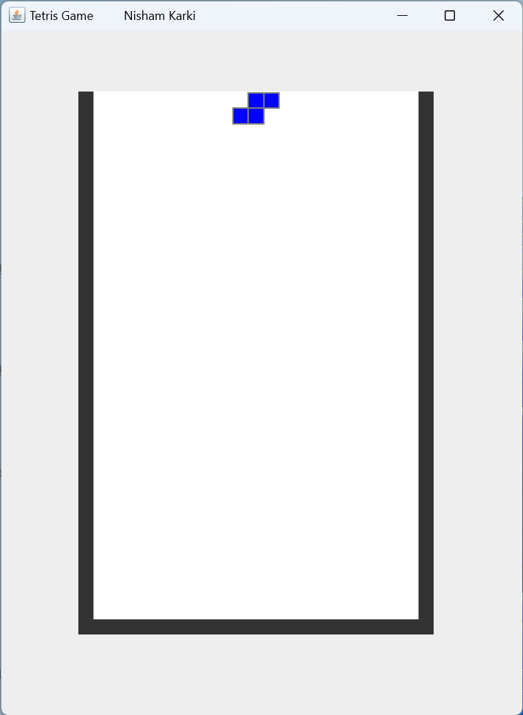

- Paste a screen shot of full tetris window showing the ZeeBrick in its initial position.

